ASD-S
10 Princess Court, Saint John, NB

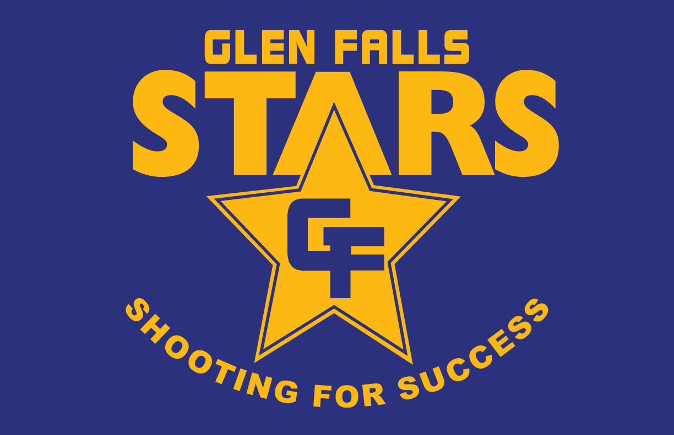
Glen Falls School Improvement Plan 2022-23
September. 2022-23

Goal 1: Academic Intervention provided to students who require support to fill gaps due to Covid-19 absences.
Strategies | Timeline | Champion | Monitoring Plan
EGLA 1 & 2  QPS  Phono Screener  Science of Reading  Intervention Lessons  Math Benchmarks | 2022-23 |  | Testing during reporting periods  Regular progress monitoring  Teacher observations  PLC- PL and Discussions
Goal 2: K-2 teachers will take part in the new EGLA assessment and the 3-5 teachers will continue to use the QPS and Phono screener. To provide better data driven instruction.
Strategies | Timeline | Champion | Monitoring Plan
EGLA 1 & 2  QPS  Phono Screener  Science of Reading  Intervention Lessons  Math Benchmarks | 2022-23  Staff survey  PL for Staff  Staff exit surveys.  Student surveys  Power School Data  Student products | Mandi Pitman  Krista Meloro | PLC- PL and Discussions  Webinars
Goal 3: Increase the sense of school connectedness among our families and greater school community.
Strategies | Timeline | Champion | Monitoring Plan
Monthly parent meetings  Variety of family events | 2022-23 | Sara Hayward and ESS Team  Staff | Attendance collection at events.

